**Laporan Praktikum**

**Pemrograman Web 1**

**Modul 2 : FORM HTML**

**( *Dosen Pengampu : Yati Nurhayati, S.Kom., M.Kom.*)**



**Nama : Anjar Tejakusumah**

**NIM : 20230810128**

**Kelas : TINFC-2023-04**

**Program Studi Teknik Informatika**

**Fakultas Ilmu Komputer**

**Universitas Kuningan**

**2024**

**PRAKTIKUM**

1. **Praktikum 1**

**Code :**

|  |
| --- |
| <!DOCTYPE html>  <html lang="id">  <head>      <meta charset="UTF-8">      <meta name="viewport" content="width=device-width, initial-scale=1.0">      <title>Form Input Teks</title>  </head>  <body>      <h1>Form Input Data Mahasiswa</h1>      <form method="get" action="M2-1.html">          <table border="0">              <tr>                  <td><label for="inputText">Nomor Induk Mahasiswa</label></td>                  <td>                      <input type="number" id="nim" name="nim" pattern="[0-9]" required>                  </td>              </tr>              <tr>                  <td><label for="inputText">Nama</label></td>                  <td>                      <input type="text" id="nama" name="nama" maxlength="35" min="5" size="50" required>                      <span>Harus 5-35 karakter</span>                  </td>              </tr>              <tr>                  <td><label for="inputText">Password</label></td>                  <td>                      <input type="password" id="pass" name="pass" maxlength="20" min="5" size="40" pattern="(?=.*[a-zA-Z])(?=.*[0-9])(?=.*[!@#]).+" required />                      <span>Harus berisi kombinasi huruf, angka, dan simbol</span>                  </td>              </tr>              <tr>                  <td><label for="inputText">Nomor Telepon</label></td>                  <td>                      <input type="tel" id="telp" name="telp" maxlength="12" min="10" pattern="08.*" placeholder="08xxxx" required />                      <span>Harus 10-12 karakter</span>                  </td>              </tr>              <tr>                  <td><label for="inputText">E-Mail</label></td>                  <td>                      <input type="email" id="e_mail" name="e_mail" placeholder="nama@contoh.com" required />                  </td>              </tr>              <tr>                  <td><label for="inputText">Alamat</label></td>                  <td>                      <textarea name="alamat" cols="35" rows="5"></textarea>                  </td>              </tr>              <tr>                  <td colspan="2">                      <button name="save" value="simpan">SIMPAN</button>                      <button type="reset" name="cancel" value="batal">BATAL</button>                  </td>              </tr>          </table>      </form>  </body>  </html |

**Hasil**

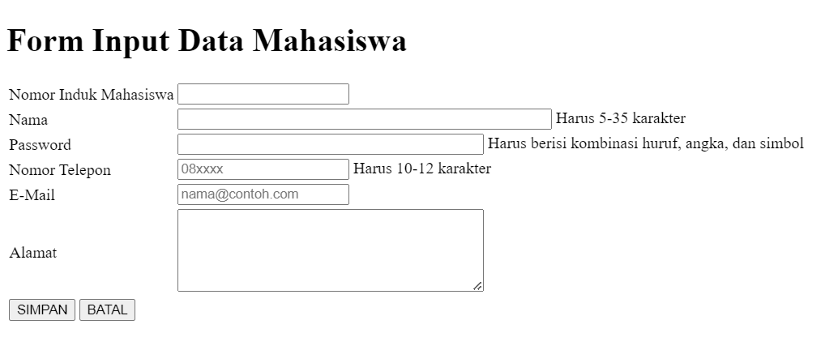

1. **Praktikum 2**

**Code :**

|  |
| --- |
| <!DOCTYPE html>  <html lang="id">  <head>      <meta charset="UTF-8" />      <meta name="viewport" content="width=device-width, initial-scale=1.0" />      <title>Radio Button</title>  </head>  <body>      <h1>Form Pilih Jenis Pembayaran</h1>      <form method="get">          <div>              <label for="input">Pembayaran</label>          </div>          <div>              <input type="radio" id="paymentMethod" name="paymentMethod" value="credit card" />Credit Card <br />              <input type="radio" id="paymentMethod" name="paymentMethod" value="debit" checked />Debit <br />              <input type="radio" id="paymentMethod" name="paymentMethod" value="transfer" />Transfer <br />              <input type="radio" id="paymentMethod" name="paymentMethod" value="ovo" />Ovo          </div>          <div>              <button name="save" value="simpan">SIMPAN</button>              <button type="reset" name="cancel" value="batal">BATAL</button>          </div>      </form>  </body>  </html> |

**Hasil**

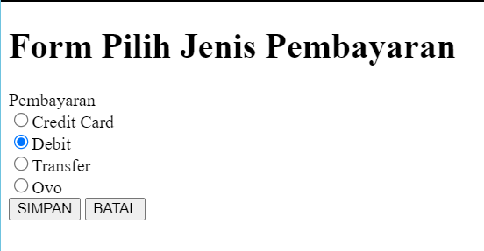

1. **Praktikum 3**

**Code :**

|  |
| --- |
| <!DOCTYPE html>  <html lang="id">  <head>      <meta charset="UTF-8" />      <meta name="viewport" content="width=device-width, initial-scale=1.0" />      <title>Checkbox</title>  </head>  <body>      <h1>Form Pilih Warna</h1>      <form method="get">          <div>              <label for="input">Warna Kesukaan</label>          </div>          <div>              <input type="checkbox" id="Warna" name="Warna" value="merah">merah <br />              <input type="checkbox" id="Warna" name="Warna" value="hijau">hijau <br />              <input type="checkbox" id="Warna" name="Warna" value="kuning">kuning <br />              <input type="checkbox" id="Warna" name="Warna" value="biru">biru <br />          </div>          <div>              <button name="save" value="simpan">SIMPAN</button>              <button type="reset" name="cancel" value="batal">BATAL</button>          </div>      </form>  </body>  </html> |

**Hasil**

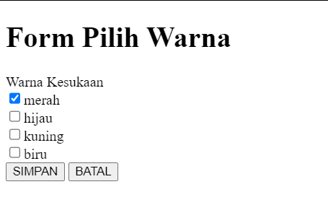

1. **Praktikum 4**

**Code :**

|  |
| --- |
| <!DOCTYPE html>  <html lang="id">  <head>      <meta charset="UTF-8">      <meta name="viewport" content="width=device-width, initial-scale=1.0">      <title>Dropdown</title>  </head>  <body>      <h1>Form Input Program Studi</h1>      <form method="get">          <div>              <label for="input">Program Studi</label>          </div>          <div>              <select name="prodi">                  <option value="-"--Pilih Salah Satu--></option>                  <option value="ti" selected>Teknik Informatika</option>                  <option value="si">Sistem Informasi</option>                  <option value="dkv">Desain Komunikasi Visual</option>                  <option value="ts">Teknik Sipil</option>              </select>          </div>          <br />          <div>              <button name="save" value="simpan">SIMPAN</button>              <button type="reset" name="cancel" value="batal">BATAL</button>          </div>      </body>  </html> |

**Hasil**

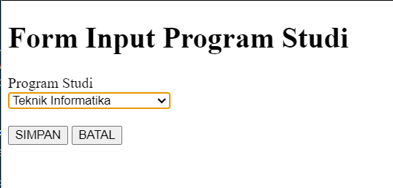

1. **Praktikum 5**

**Code :**

|  |
| --- |
| <!DOCTYPE html>  <html lang="id">  <head>      <meta charset="UTF-8">      <meta name="viewport" content="width=device-width, initial-scale=1.0">      <title>Tombol pada HTML</title>  </head>  <body>      <h1>Form Jenis Tombol</h1>      <form method="get" action="m2-2.html">          <div>              <button name="save" value="simpan"              style="background-color: rgb(56, 240, 90);">SIMPAN</button>          </div>          <br />          <div>              <button type="reset" name="cancel" value="batal"              style="background-color: yellow;">BATAL</button>          </div>          <br />          <div>              <a href="m2-3.html">                  <button type="button" name="tombol" value="cek"                  style="background-color: rgb(19, 7, 234);">CEK</button>              </a>          </div>          </form>      </body>  </html> |

**Hasil**

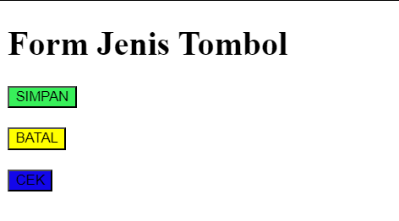

**TUGAS INDIVIDU**

1. **Buat form Pemesanan, dengan tampilan sebagai berikut :**

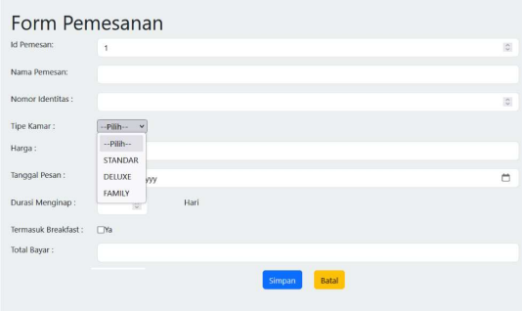

1. **Buat form untuk tambah data :**
2. **Data kamar, berisi : id kamar, gambar ruangan, jenis kamar, harga, fasilitas.**
3. **Fasilitas, berisi :id, nama, fasilitas, harga weekend, harga weekday, kuota, jam buka, jam tutup**

**Jawaban**

1. Untuk menampilkan form pemesanan seperti di soal, maka masukan kode berikut

Code :

|  |
| --- |
| <!DOCTYPE html>  <html lang="id">    <head>      <meta charset="UTF-8" />      <meta name="viewport" content="width=device-width, initial-scale=1.0" />      <title>Form Pemesanan</title>    </head>    <body>      <div class="form-container">        <h1>Form Pemesanan</h1>        <form>          <table>            <tr>              <td><label for="id-pemesanan">ID Pemesan :</label></td>              <td><input type="number" id="durasi" min="1" required /></td>            </tr>            <tr>              <td><label for="nama-pemesan">Nama Pemesan :</label></td>              <td><input type="text" id="nama-pemesan" required /></td>            </tr>            <tr>              <td><label for="nomor-identitas">Nomor Identitas :</label></td>              <td><input type="number" id="durasi" min="1" required /></td>            </tr>            <tr>              <td><label for="tipe-kamar">Tipe Kamar :</label></td>              <td>                <select id="tipe-kamar" required>                  <option value="">-- Pilih --</option>                  <option value="standar">STANDAR</option>                  <option value="deluxe">DELUXE</option>                  <option value="family">FAMILY</option>                </select>              </td>            </tr>            <tr>              <td><label for="tanggal-pesan">Tanggal Pesan :</label></td>              <td><input type="date" id="tanggal-pesan" required /></td>            </tr>            <tr>              <td><label for="durasi">Durasi Menginap :</label></td>              <td>                <input type="number" id="durasi" name="durasi" min="1" required />                <span> Hari </span>              </td>            </tr>            <tr>              <td><label for="breakfast">Termasuk Breakfast?</label></td>              <td><input type="checkbox" id="breakfast" />                <span> Ya </span>              </td>            </tr>            <tr>              <td><label for="total-bayar">Total Bayar</label></td>              <td><input type="text" id="total-bayar" readonly /></td>            </tr>            <tr>              <td colspan="2" align="center">                <button                type="submit" name="tombol" value="cek" style="background-color: blue; color: white;">Simpan              </button>                <button                type="reset" name="tombol" value="cek" style="background-color: red; color: white;">Batal                </button>              </td>            </tr>          </table>        </form>      </div>    </body>  </html> |

**Hasil**

1. Untuk hasilnya tidak akan sama percis seperti di gambar soal, karena kode diatas hanya kode HTML nya saja, sedangkan jika ingin sama seperti di soal maka harus menambahkan CSS, hasul dari kode diatas adalah seperti gambar dibawah.

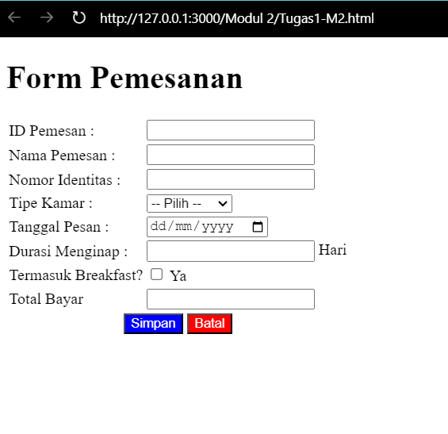

1. **Form tambah Data**
2. Form data kamar

Code :

|  |
| --- |
| <!DOCTYPE html>  <html lang="id">    <head>      <meta charset="UTF-8" />      <meta name="viewport" content="width=device-width, initial-scale=1.0" />      <title>Form Tambah Data</title>    </head>    <html>      <h1>Tambah Data Kamar</h1>      <form>        <table>          <tr>            <td><label for="id-kamar">ID Kamar :</label></td>            <td>              <input type="number" id="id-kamar" name="id-kamar" required />            </td>          </tr>          <tr>            <td><label for="gambar-ruangan">Gambar Ruangan :</label></td>            <td>              <img src="./download (1).jpg" alt="gambar ruangan1" />              <img src="./download (2).jpg" alt="gambar ruangan2" />            </td>          </tr>          <tr>            <td><label for="jenis-kamar">Jenis Kamar :</label></td>            <td>              <input type="text" id="jenis-kamar" name="jenis-kamar" required />            </td>          </tr>          <tr>            <td><label for="harga">Harga :</label></td>            <td><input type="number" id="harga" name="harga" required /></td>          </tr>          <tr>            <td><label for="fasilitas">Fasilitas :</label></td>            <td>              <textarea                id="fasilitas"                name="fasilitas"                rows="3"                required>              </textarea>            </td>          </tr>          <tr>            <td colspan="2" align="center">              <button                type="submit"                name="tombol"                value="cek"                style="background-color: blue; color: white">Simpan              </button>              <button                type="reset"                name="tombol"                value="cek"                style="background-color: red; color: white">Batal              </button>            </td>          </tr>        </table>      </form>  </html> |

**Hasil**

1. Kode HTML di atas menampilkan sebuah halaman sederhana berjudul "Form Tambah Data" dengan sebuah form untuk menambahkan data kamar hotel. Form ini menggunakan elemen tabel untuk mengatur tata letak setiap field, termasuk "ID Kamar," "Gambar Ruangan," "Jenis Kamar," "Harga," dan "Fasilitas." Formulir ini juga menyediakan area teks untuk memasukkan informasi fasilitas dan menampilkan dua gambar sebagai contoh ruangan, tampilan hasilnya seperti gambar dibawah.

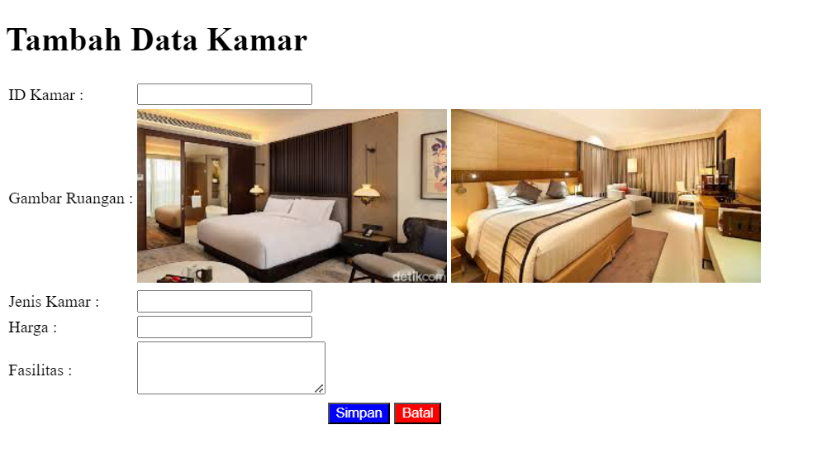

1. Form data Fasilitas

Code :

|  |
| --- |
| <!DOCTYPE html>  <html lang="id">    <head>      <meta charset="UTF-8" />      <meta name="viewport" content="width=device-width, initial-scale=1.0" />      <title>Form Tambah Data</title>    </head>    <html>  <h1>Tambah Data Fasilitas</h1>  <form>    <table>      <tr>        <td><label for="id">ID :</label></td>        <td><input type="number" id="id" name="id" required /></td>      </tr>      <tr>        <td><label for="nama">Nama :</label></td>        <td><input type="text" id="nama" name="nama" required /></td>      </tr>      <tr>        <td><label for="fasilitas">Fasilitas :</label></td>        <td>          <textarea            id="fasilitas"            name="fasilitas"            rows="3"            required>          </textarea>        </td>      </tr>      <tr>        <td><label for="harga-weekend">Harga Weekend :</label></td>        <td>          <input            type="number"            id="harga-weekend"            name="harga-weekend"            required/>        </td>      </tr>      <tr>        <td><label for="harga-weekday">Harga Weekday :</label></td>        <td>          <input            type="number"            id="harga-weekday"            name="harga-weekday"            required/>        </td>      </tr>      <tr>        <td><label for="kuota">Kuota :</label></td>        <td><input type="number" id="kuota" name="kuota" required /></td>      </tr>      <tr>        <td><label for="jam-buka">Jam Buka :</label></td>        <td><input type="time" id="jam-buka" name="jam-buka" required /></td>      </tr>      <tr>        <td><label for="jam-tutup">Jam Tutup :</label></td>        <td>          <input type="time" id="jam-tutup" name="jam-tutup" required />        </td>      </tr>      <tr>        <td colspan="2" align="center">          <button            type="submit"            name="tombol"            value="cek"            style="background-color: blue; color: white">Simpan          </button>          <button            type="reset"            name="tombol"            value="cek"            style="background-color: red; color: white">Batal          </button>        </td>      </tr>    </table>  </form>  </body>  </html> |

**Hasil**

1. Kode HTML diatas membuat form "Tambah Data Fasilitas" yang mengumpulkan data seperti ID, nama, fasilitas, harga (weekend dan weekday), kuota, serta jam buka dan tutup. Setiap field wajib diisi (required), dan ada dua tombol, "Simpan" dan "Batal," untuk mengirim atau mereset data, tampilan hasilnya seperti gambar dibawah.

